Network Analysis of Causes of Death Across Countries
Yann Lukas Hinsche, Yiwen Zhang, Aryan Patel
This paper analyses patterns of association among cause-specific mortality rates across countries. A network containing 139 causes of death for 182 countries was constructed and compared with health-system indicators.

Background
Cause of death strongly differs between countries, with communicable, maternal, neonatal and nutritional conditions accounting for 31% of the total age-standardized mortality rate in low-income countries, only for 7% in high-income countries [1]. Networks are a tool commonly used to study which diseases occur together in the same patients [2, 3]. This paper focuses on applying this approach to a country level on a global scale, with focus on answering the questions below:
1.How are different causes of death associated across countries?
2.Which disease associations remain after accounting for economic development?
3.Can we identify meaningful disease communities with health indicators?

Data & Methods
The data used within the project stems from four public sources:
- Death rates for all causes from WHO Global Health Estimates [1],
- Health-system and risk-factor indicators from the WHO Global Health Observatory [4],
- Economic Indicators from the World Bank [5],
- Human Development Index (HDI) from “Our World in Data” [6].
The death rates are age-standardized and given per 100,000 people. The Year 2019 was used since it is the last year before COVID-19 and a year with significantly more data available from WHO sources. For other indicators, the latest values between 2013 and 2019 were used. For indicators with missing data (aprox. 3%), group wise median imputation was used to fill based on the median of the country’s income group. Furthermore, log transform log(1 + x) was used to remove skewness from data for the final EDA, with the dataset to containing 182 countries, 139 causes of death and 71 indicators.
As rich and poor countries differ significantly in all causes of death variables are adjusted based on GDP per capita and its residuals. The correlation of the residuals therefore is the partial spearman correlation.
Based on the data, two networks were constructed where each cause of death is a separate node. In the co-occurrence network two causes are linked if their partial correlation is at least 0.35. The graphical lasso network [7] estimates conditional associations between causes, retaining edges above an absolute partial-correlation threshold of 0.05. Its regularization penalty was selected using five-fold cross-validation.
The communities were detected using the Louvain method [8], the countries were sampled and rebuilt 200 times within a network, to assess community reproducibility. Finally, 65 indicators were linked to correlate using $\left|ρ\right| ≥0.35$ and medical links were checked based on medical research. Within the analyses, pandas, scikit-learn [9] and NetworkX [10] were used as tools.
Causes with zero mortality in at least 90% of countries or a maximum rate below 0.5 per 100,000 were excluded. Aggregate categories were also removed to reduce hierarchical redundancy. The causes themselves are additionally also split into what caused the disease. The death assignment itself is based on WHO guidelines, as the source of data.

Results
Before GDP adjustment, 27% of disease pairs had strong correlations ($\left|ρ\right| ≥0.5$), compared with only 2% afterward (Figure 1). This suggests that economic development is associated with a substantial share of observed mortality correlations.
The co-occurrence network formed 918 links and a total of 6 communities and the direct-link network 443 links and 11 communities. An example shown in Figure 2, the correlation between drowning and HIV, was high in the co-occurrence network while being low in the graphical lasso.
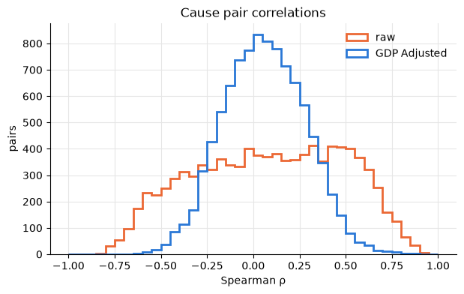
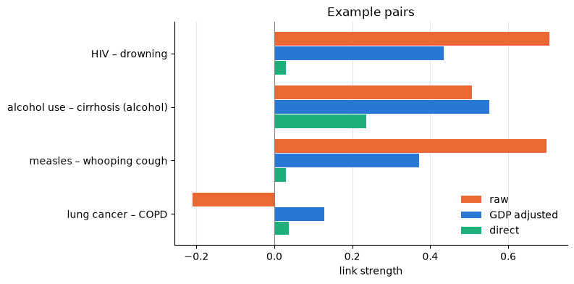
Figure 1 – Pair Correlation between pairs by causes of death, before and after adjusting for GDP per capita
Figure 2 – Link strength of four pairs, raw correlation adjusted for GDP and direct links

From Figure 2 we can infer that Lung cancer and COPD have the same main cause, which is smoking, but almost no direct link. The graphical lasso, while removing false links also removed some real links when compared to the co-occurrence network, due to the correlation being computed given all other causes, when compared to expected medical data. Therefore, some medically expected associations disappear in the conditional-dependence based network.
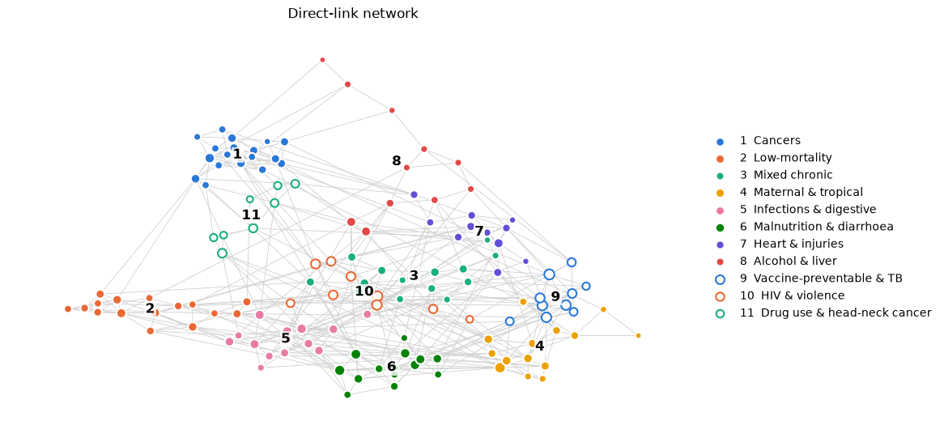
Figure 3 - Direct link network of 139 causes of death
In Figure 3 we can observe the direct-link network, where most communities are unstable (Figure 4). For example, the cancer community reached approximately 90% average pairwise co-assignment probability across bootstrap samples, while other communities showed substantially lower stability (Figure 4). From this it can be inferred that only certain disease communities have a reproducible structure.
Of the 29 expected indicator links, chosen based on known medical relationships, 23 have an expected sign and 11 pass the threshold of 0.35 (Figure 5). Risk factors show strong links, for example TB incidence and tuberculosis and tobacco use and lung cancer. Available treatments indicators, such as dialysis and insulin, did not show strong associations under the selected threshold.
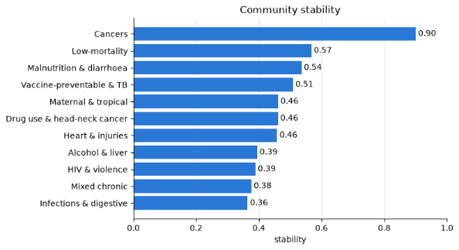
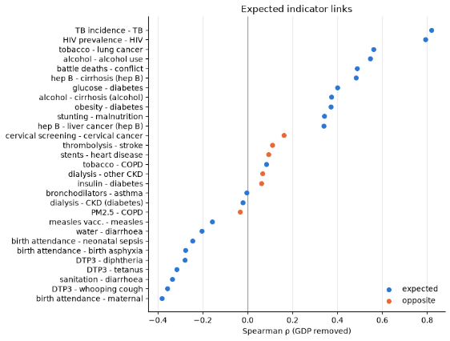
Figure 4 – Average pairwise co-assignment probability across 200 samples
Figure 5 - Expected links between indicators and cause of death

Conclusion
Most correlations of causes of death are explained by the split in wealth of low-income and high-income countries. Therefore, after adjusting the data for wealth, links between obesity and diabetes for example become more apparent.
This shows that the structure of the health system is associated with mortality patterns beyond national differences. Sanitation and number of doctors are each linked to lower deaths in multiple causes at the same income level. Other causes of death, such as liver deaths and cardiovascular deaths are linked to specific risk factors. The network shows how different conditions interact with each other, how the groups connect and how multiple conditions with known interventions (alcohol use and drug use disorders) are linked to several groups at once. Some links between causes of death still represent the regions, such as the link between obesity and malaria. A visual representation of the network is available online [11].
One limitation, which needs to be mentioned however is that the network is built on data from 2019, therefore represents majorly that year. Another limitation is that the study focuses on associations between countries, not patients or causal effects. While two diseases may share the same risk factors, they might not affect each other.
Future research could focus on using the links to predict how changes in certain factors reduce mortality across diseases. Furthermore, the networks could be expanded and methods such as causal inference approaches could be used to estimate how treatment of a disease could affect other diseases and identify the regions where such treatment yields the best result.

Acknowledgements
We would like to thank the World Health Organization, World Bank and Our World in Data for making the data publicly accessible and available for academic work. Furthermore, Claude by Anthropic was used to assist with the code generation for visuals and the networks throughout the analysis.

References
[1] |  | World Health Organization, ‘Mortality and Global Health Estimates’, www.who.int. Accessed: Oct. 28, 2026. [Online]. Available: https://www.who.int/data/gho/data/themes/mortality-and-global-health-estimates
[2] |  | K.-I. Goh, M. E. Cusick, D. Valle, B. Childs, M. Vidal, and A.-L. Barabási, ‘The Human Disease Network’, Proceedings of the National Academy of Sciences, vol. 104, no. 21, pp. 8685–8690, May 2007, doi: 10.1073/pnas.0701361104.
[3] |  | C. A. Hidalgo, N. Blumm, A.-L. Barabási, and N. A. Christakis, ‘A Dynamic Network Approach for the Study of Human Phenotypes’, PLoS Comput Biol, vol. 5, no. 4, p. e1000353, Apr. 2009, doi: 10.1371/journal.pcbi.1000353.
[4] |  | World Health Organization, ‘GHO OData API’, www.who.int. Accessed: Oct. 28, 2026. [Online]. Available: https://www.who.int/data/gho/info/gho-odata-api
[5] |  | World Bank, ‘World Development Indicators’, The World Bank. Accessed: Oct. 28, 2026. [Online]. Available: https://databank.worldbank.org/source/world-development-indicators
[6] |  | E. Ortiz-Ospina, Roser, M., and World Health Organization, ‘The Universal Health Coverage (UHC) Service Coverage Index’, Our World in Data. Accessed: Oct. 28, 2026. [Online]. Available: https://archive.ourworldindata.org/20260910-013942/grapher/universal-health-coverage-index.html
[7] |  | J. Friedman, T. Hastie, and R. Tibshirani, ‘Sparse Inverse Covariance Estimation With the Graphical Lasso’, Biostatistics, vol. 9, no. 3, pp. 432–441, Dec. 2007, doi: 10.1093/biostatistics/kxm045.
[8] |  | V. D Blondel, J.-L. Guillaume, R. Lambiotte, and E. Lefebvre, ‘Fast Unfolding of Communities in Large Networks’, Journal of Statistical Mechanics: Theory and Experiment, vol. 2008, no. 10, p. P10008, Oct. 2008.
[9] |  | F. Pedregosa et al., “Scikit-learn: Machine Learning in Python,” Journal of Machine Learning Research, vol. 12, pp. 2825–2830, 2011. [Online]. Available: https://www.researchgate.net/publication/51969319_Scikit-learn_Machine_Learning_in_Python
[10] |  | A. A. Hagberg, D. A. Schult, and P. J. Swart, ‘Exploring Network Structure, Dynamics, and Function Using NetworkX’, Proceedings of the Python in Science Conference, pp. 11–15, Jun. 2008, doi: 10.25080/tcwv9851.
[11] | Y. L. Hinsche, Y. Zhang, and A. Patel, ‘Network Analysis of Causes of Death across Countries’. Accessed: Oct. 28, 2026. [Online]. Available: https://github.com/Yalu64/FS-MADS-IDA-Network-Analysis-of-Causes-of-Death-Across-Countries

